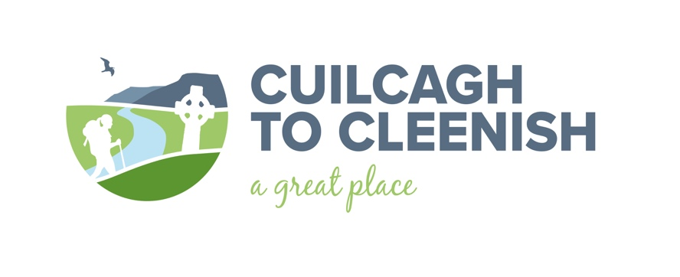
Event schedule for Spring 2019.
History and Heritage Talks. All talks are free. More to come…
Date | Title | Speaker | Details | Venue | Booking
Thursday 4th April 8.00pm. | Cuilcagh to Cleenish: A Great Place Heritage audit. | Seamas McCanny  researcher, author, and story teller. | The story so far. Come along and hear what the heritage audit has uncovered…. Join in, tell your story and add a piece to the jigsaw. | Larganess Centre  Florence Court. | Refreshments served. No booking required.
Thursday 18th April  8.30pm. | Reading our Landscape: Heritage talk. | Dr. Liam Campbell  Lough Neagh Landscape Partnership. | Reading the landscape around us can tell us much about ourselves and where we came from. | Cleenish Parish Hall  Derrylin Road  Bellanaleck. | Refreshments served. To book:
Thursday 16th May  8.00pm. | Bundle rush rafts on Lough Erne: Heritage talk. | Rob Henshall  Archaeologist | Rush rafts were most likely used from the earliest of times in Fermanagh as a form of personal transport, communication and hunting. | Larganess Centre  Florence Court. | Refreshments served. To book:

Give it a Go!
All events are free. Numbers are limited so early booking is advised.
Date | Title | Provider | Details | Venue | Booking
Saturday 27th April  10.00am – 4.00pm. | 3D modelling. | Digital Heritage Age. | A photogrammetry course for young people age 12-18. Learn to use a camera to make 3d models of artefacts held in the museums’ collection from the C2C area. For more information: | Castle Museum  Enniskillen. | Numbers limited to twelve. Bring your own phone charging USB or transfer cable.
Saturday 4th May  10.00am – 4.00pm. | Row Cleenish. | Row the Erne. | Row around Cleenish Island with a professional crew on board the Menapian. Experience Upper Lough Erne from the water and hear about the island’s rich heritage and history. Weather dependent.www.facebook.com/RowingTheErne/ | Meet at Bellanaleck Marina. | Numbers limited to ten.
Saturday 11th May  10.00 am | Arney River canoe trip. | Erne Paddlers. | Experience the river wildlife from the water. Paddle from Arney Bridge to Upper Lough Erne. Open to people of all ages. Equipment provided. Weather dependent. | Arney Bridge. | Numbers limited to fifteen.
Saturday 11th May  10.00 am -12.00 noon. | Discover our natural heritage: Guided walking tour. | Marble Arch Caves UNESCO Global Geopark. | Claddagh Glen. Distance: 2.5km. Time: 1.5 hrs. Gravel pathway, boardwalk & steps. Grade: Easy/moderate. A linear walk with some inclines and steps along existing gravel pathway and boardwalk. Wear warm waterproof clothing and suitable footwear. Children must be accompanied by an adult. | Meet at Marble Arch Caves visitor centre. | Numbers limited to twenty.
Saturday 18th May  10.00 am -12.00 noon. | Discover our natural heritage: Guided walking tour. | Marble Arch Caves UNESCO Global Geopark. | Gortmaconnell and Owenbrean. Distance: 5.6kms Time: 2 hours. Farm track. Grade: moderate to difficult. Suitable for walkers with moderate levels of fitness. Wear warm waterproof clothing and suitable footwear. Not suitable for children under 12 years old. | Meet at Marble Arch Caves visitor centre. | Numbers limited to twenty.
For more details or to book a place contact: Barney Devine 07734847470
barney@c2c.org.uk
www.facebook.com/c2cgp/
www.c2c.org.uk

The Cuilcagh to Cleenish: A Great Place Project is supported by the National Lottery Heritage Fund and Fermanagh and Omagh District Council. The project is being delivered in partnership by Outdoor Recreation Northern Ireland (lead partner), Cleenish Community Association, Killesher Community Development Association and Fermanagh and Omagh District Council through the resources of the Marble Arch Caves UNESCO Global Geopark.

